Zombie Raid

A Senior Project Submitted in Partial Fulfillment of the Requirements for the Bachelor’s Degree

in

Computer Science  
Department of Computer Science

Faculty of Natural and Applied Sciences  
Notre Dame University – Louaize Barsa, Lebanon

Anthony Tleiji

Oscar Radi

Bernard El Hage

May 2022



**Dedication**

We dedicate this project to our Dear Drs. who followed us on our 3-years journey and helped us climb the CS ladder step-by-step:

Mr. Bachir Maroun

Dr. Marie Khair

**Abstract**

The team’s composed of 3 members, each with his own role, crucial for the making of this project. Oscar Radi: Game Developer, Bernard El Hage: Front-end Developer, Anthony Tleiji: Back-end & Database Developer.

The project consists of a video game (Zombie-shooter), which is at the core, accompanied by a website so users can access certain data and perform some actions without having to log onto the game (such as registration/statistics). Both the Game and the Website are connected to the same Backend which provides all required functionalities and connection with the database.

The player signs in with an account to play the game. The game is a third person zombie shooter, where the player fights against endless waves of zombies in order to get the highest score possible. Player data will be saved on a database that will then be accessed by the website.

The website is a complementary component to the game which enhances their gaming experience by providing neat data such as Leaderboards, Statistics which make gaming more competitive and enjoyable. In addition to providing a real-time Chat Room feature so gamers can easily communicate and share new ideas.

The game and the website are both connected to the same backend, making use of the provided APIs, which complies with modern standards of system layering and structuring.

One key concept we followed through this project is modularity. From the front-end (website/game) to the backend, all parts of this project are easily reusable.

Most of our work was done through online communication, tasks, and weekly meetings.

**Keywords**: [API, modularity]

***Table of Contents***

Chapter 1 : Business Vision, Glossary, and Risks 1

1.1 Introduction 1

1.2 Definitions, Acronyms, and Abbreviations 1

1.2.1 API 1

1.2.2 TPS 1

1.3 Positioning 1

1.3.1 Business Opportunity 1

1.3.2 Problem Statement 1

1.3.3 Product Position Statement 2

1.4 Senior Study Objective 2

1.5 Approach 3

1.6 Risks 3

1.6.1 Lack of funds 3

Chapter 2 : Background 5

2.1 Introduction 5

2.2 User Summary and Competition 5

2.2.1 User Summary 5

2.2.2 Alternatives and Competition 6

2.3 Ethics 6

2.4 Impact on Society 6

2.5 Other Requirements 6

2.5.1 Applicable Standards 6

2.5.2 System Requirements 6

2.5.3 Performance Requirements 7

2.6 Conclusion 7

Chapter 3 : Requirements Elicitation 9

3.1 Introduction 9

3.2 Adopted Technique(s) 9

3.2.1 Comparison Methodology 9

3.3 Conclusion 10

Chapter 4 : Enumerated Requirements and Increments 11

4.1 Introduction 11

4.2 Functional Requirements 11

4.3 Non-Functional Requirements 12

4.5 Increments 13

4.5.1 Release Backlogs 13

4.5.2 Sprints 14

4.6 Conclusion 15

Chapter 5 : Functional Requirements Specification 16

5.1 Introduction 16

5.2 Use Case Diagram 16

5.3 Use Case Specification for Login 17

5.3.1 Brief Description 17

5.3.2 Actors 17

5.3.3 Basic Flow of Events 17

5.3.4 Alternative Flows of Events 17

5.3.5 Special Requirements 17

5.3.6 Preconditions 17

5.3.7 Postconditions 17

5.3.8 Extension Points 18

5.4 Conclusion 18

Chapter 6 : Domain Analysis 19

6.1 Introduction 19

6.2 System Class Diagram 19

6.2.1 Class Diagram Breakdown 19

6.2.2 Why is Chat not stored in a table? 20

6.3 Conclusion 20

Chapter 7 : Interaction and Data Flow Diagrams 21

7.1 Introduction 21

7.2 Sequence Diagrams 21

7.2.1 Login Sequence Diagram 21

7.3 Data Flow Diagram 22

22

7.4 Conclusion 22

Chapter 8 : Software Architecture and Design 23

8.1 Introduction 23

8.2 Physical Tiers 23

8.3 Logical Layers 23

8.4 Architectural Patterns 23

8.5 Conclusion 24

Chapter 9 : User Interface Design 25

9.1 Introduction 25

9.2 Preliminary UI Sketches 25

9.2.1 Chat Room 25

9.2.2 Game Login Screen 26

9.3 Final UI Design 27

9.3.1 Chat Room 27

9.3.2 Home Page 27

27

9.3.3 Website Login and Registration Screens 28

9.3.4 Website Account Screens 29

9.3.5 Final Game Login Screen 29

9.3.5 Final in Game UI And Environment 30

9.4 Conclusion 30

Chapter 10 : Coding Samples 31

10.1 Introduction 31

10.2 Code Blocks 31

10.2.1 Socket.io 31

10.2.2 Login Service (user.service.js) 32

10.2.3 Get User Score by Email Service (score.service.js) 32

10.2.4 Login Stored Procedure (MSSQL) 33

10.3 Conclusion 33

Chapter 11 : Collaboration and Individual Contribution 34

11.1 Introduction 34

11.2 Collaboration Approach 34

11.3 Problems that Occurred 34

11.4 Individual Contribution Breakdown 35

11.5 Conclusion 35

Chapter 12 : Detailed Game Breakdown 36

12.1 Introduction 36

12.2 Framework 36

12.2.1 Methodologies 36

12.3 Zombie Raid Development Samples 37

12.3.1 Equip Weapon Blueprint 37

12.3.2 Equip Weapon Blueprint 37

12.3.3 Zombie Deal Damage Blueprint Function 38

12.3.4 Login HTTP POST Request Blueprint 39

12.3.5 Create Score HTTP POST Request Blueprint 40

12.4 Game Demo 40

Chapter 13 : Detailed Frontend Breakdown 41

13.1 Introduction 41

13.2 Framework 41

13.2.1 Methodologies 41

13.2.2 Project Structure 42

13.2.3 Development Steps 42

13.3 Chat Demo 46

Chapter 14 : Detailed Backend Breakdown 46

14.1 Introduction 47

14.2 Framework 47

14.2.1 Backend Layers 47

14.3 Database 48

14.3.1 Stored Procedures 49

14.4 Data Access Layers and Stored Procedures 49

14.5 Socket io 51

14.6 API Testing 53

14.6.1 Postman Structure 53

14.6.2 Postman and improving team efficiency 54

14.7 Version Control and Open Sourcing 55

Chapter 15 : Conclusions and Recommendations 56

15.1 Summary of the Main Results 56

15.2 Main Contributions 56

15.3 Possible Extensions and Future Work 56

**Links:**

1. [**Trailer**](https://www.youtube.com/watch?v=Yn22OP8VYoE)
2. [**Chat Demo**](https://www.youtube.com/watch?v=Pgwe-EEpxB8)
3. [**Gameplay**](https://www.youtube.com/watch?v=Z0wta5W_g5c)

# : Business Vision, Glossary, and Risks

## Introduction

Our goal is to provide a game built by gamers for gamers while maintaining the best possible user experience through a companion website that pushes users to be engaged, competitive and sociable with other players.

## Definitions, Acronyms, and Abbreviations

### API

Application programming interface which serves as the link between user interfaces and the business logic.

### TPS

Third person shooter: which is a shooting game genre where the player is fully visible on the screen.

## Positioning

### Business Opportunity

This game and companion website have a huge potential in the gaming market as an easily scalable project.

### Problem Statement

Table 1.1: Problem Statement

|  |  |
| --- | --- |
| The problem of | Lack of games providing user interaction outside the game. |
| affects | Every single gamer |
| the impact of which is | Decrease game enjoyability |
| a successful solution would be | A companion website for the game that allows external interactions. |

### Product Position Statement

Table 1.2: Product Positioning

|  |  |
| --- | --- |
| For | Gamers |
| Who | Enjoy competition |
| Zombie Raid | is a third person shooter game |
| That | Delivers better user experience with intractability |
| Unlike | Other games like Call of Duty |
| Our product | Offers all the lacking features (chatroom…) |

## Senior Study Objective

Our goal with this project was to put our skills to test, mixing and matching every bit of knowledge acquired during our Bachelor in CS journey in addition to tools and frameworks learned on the side

## Approach

The project was structed over several layers, Frontends (Game and website), APIs (providing the link between user interfaces and Business Logic), Business Logic (Provides all required functionalities using the data accessed by the Data Access Layer), Data Access Layer (direct connection with the database, performs queries) Database (has stored procedures to perform CRUD operations)

Frontend Frameworks: Unreal Engine (Game), Angular (Website)

Backend: Node.js Express.js

Database: SQL Server

Bonus Tools: Git, Postman, GitHub, SSMS

## Risks

### Lack of funds

Risk Magnitude or Ranking

Most damaging.

Description

Lack of funds to host the project online.

Impacts

Having to use free/cheap hosting services which could lead to slower performance with the increase of the number of users.

Indicators

System crash / slow performance.

Mitigation Strategy

Launching the project on kick starter in order to receive funds from the people interested in our game.

Contingency Plan

Shutting the project down temporarily until we have enough resources to improve our hosting service.

# : Background

## Introduction

In this chapter we will lay the foundation for the project by listing all of its users and competitors, in addition to details about potential ethical issues, its impacts on society and hardware requirements.

## User Summary and Competition

### User Summary

Table 2.1: User Summary

|  |  |  |
| --- | --- | --- |
| **Name** | **Description** | **Responsibilities** |
| Gamer | The person who decides to play the game. | Play the game  Report bugs  Give feedback |
| User | The person who uses the webapp, could also be the gamer | View Statistics  View Leaderboard  View Statistics  Chat |

### Alternatives and Competition

This part is quite tricky as in the gaming market, any game can be considered a competitor to our project. However, as direct competitor in the Zombie Shooting genre, we could identify the "big names" such as Call of Duty which also has a webapp. And as indirect competitors: World War Z, Left for Dead, back for blood, Days Gone to name a few.

## Ethics

One of the biggest ethical issues in any software project is privacy, this however, is not an issue in our project as the only data being stored is email which will not be used in any shape or form outside the game, any other data stored is data generated in-game such as scores. Chat messages sent on the public Chat Room will NOT be stored so users can feel safe sharing their ideas.

## Impact on Society

Modern-day problem gamers suffer from is the lack of social skills, this project aims to combine both, the love for competition and social interactions by providing means of chatting outside the game itself, where gamers improve on their social skills by making new friends.

## Other Requirements

### Applicable Standards

Communication: TCP/IP

Platform:

* Game: Windows/Mac
* Website: Any platform

### System Requirements

* Windows 7/8/10 (64-bit)
* 4GB RAM
* 1GB VRAM

### Performance Requirements

* Minimum (30 fps):
  + CPU: Intel i3-370M
  + GPU: Intel HD 3000
* Recommended (60 fps):
  + CPU: Intel i3-4150
  + GPU: GeForce GT 730
* High-end (144+ fps)
  + CPU: Intel i5 4460 (3.2GHz)
  + GPU: GeForce GTX 1050 Ti

## Conclusion

The following can be concluded from this chapter:

* The project’s primary audience is gamers
* Few direct competitors exist
* Many indirect competitors exist for such project
* Ethical issues can be minimalized/eliminated
* Hardware requirements are standards for the third person shooter genre

# : Requirements Elicitation

## Introduction

In this chapter, we study how we determined the requirements for our game, we define and breakdown the methodology used and why we believe it’s suitable.

## Adopted Technique(s)

Due to this project not being hosted, and determining the requirements based on the game’s performance of our devices is not enough, requirements were estimated by comparison with competitor games.

### Comparison Methodology

First, we had to define the fields of comparison which are:

* Graphics
* Sound
* Number of entities displayed on screen at given time
* Map size
* Game Mechanics
* Game size

Second, based on the fields above, we’ve picked 3 boundaries from a list of competitor games, each representing one of the following:

* An upper bound
  + The most demanding game out of the competitors
* A middle ground
  + The competitor game most similar in terms of requirements to our project.
* A lower bound
  + The competitor game with the least demanding requirements

Out of all competitor games, we determined the following as suitable bounds:

* Call Of Duty (Upper Bound)

One of the most demanding Triple A games in terms of performance.

Realistic graphics, Shooting mechanics, Sounds, Light reflection…

* World War Z: (Middle Ground)

Open-world third person zombie-shooting game with similar graphics to our project

Semi-Realistic graphics

* Valorant (Lower Bound)

Third person shooting game

One of the least-demanding shooting games ever made.

## Conclusion

We can conclude from breakdown above that the requirements chosen for our game are somewhat accurate, however, more detailed testing will be done in the future once the project is live and funded.

# : Enumerated Requirements and Increments

## Introduction

In this chapter, we define all function and non-functional requirements for this project in the form of tables, in addition to the increments and sprints.

## Functional Requirements

We list below all the implemented and upcoming functional requirements for this project, each with an ID and a priority identifier (1: critical, 4:optional)

Table 4.2.1: List of Functional Requirements

|  |  |  |
| --- | --- | --- |
| **ID** | **Priority** | **Description** |
| REQ1 | 1 | The system shall provide a chat room for users |
| REQ2 | 1 | The game shall provide all shooting mechanics |
| REQ3 | 1 | The system shall provide user authentication means |
| REQ4 | 1 | The game shall provide AI systems for zombies |
| REQ5 | 1 | The game shall provide basic movement mechanics |
| REQ6 | 2 | The system shall provide means of editing/deleting user information |
| REQ7 | 2 | The system shall provide means of storing/fetching user scores |
| REQ8 | 2 | The game shall provide rolling/dodging/climbing mechanics |
| REQ9 | 3 | The system shall provide a way for searching other users |
| REQ10 | 3 | The game shall provide powerups system |
| REQ11 | 3 | The game shall provide voice-lines for in-game actions |
| REQ12 | 4 | The system shall provide one-to-one chatting |
| REQ13 | 4 | The system shall provide a ‘friends’ system |
| REQ14 | 4 | The system shall provide means for in-game purchases |
| REQ15 | 4 | The system shall hash the passwords in the database |

## Non-Functional Requirements

We list below all the implemented and upcoming non-functional requirements for this project, each with an ID and a priority identifier (1: critical, 2: useful, 3: optional 4:upcoming)

Table 4.3.1: List of Non-Functional Requirements

|  |  |  |
| --- | --- | --- |
| **ID** | **Priority** | **Description** |
| REQ1 | 1 | Responsive User Interface |
| REQ2 | 1 | Interactive User Experience |
| REQ3 | 1 | Developed with Scalability in mind |
| REQ4 | 1 | Level 2 - advanced protection Security |

## Increments

### Release Backlogs

The following are the backlogs we created to complete this project, the first one is the Core Features Backlog which holds all critical requirements of this project, followed by backlogs 1 and 2 which hold the lower-priority requirements.

Table 4.5.1.1: Core Features Release Backlog

This table contains the critical requirements for this project (priority: 1)

|  |  |  |  |  |  |
| --- | --- | --- | --- | --- | --- |
| **Requirement IDs** | | | | | |
| REQ1 | REQ3 | REQ3 | REQ4 | REQ5 |  |
|  |  |  |  |  |  |

Table 4.5.1.2: Release Backlog 1

This table contains useful but not critical requirements for this project (priority: 2)

|  |  |  |  |  |  |
| --- | --- | --- | --- | --- | --- |
| **Requirement IDs** | | | | | |
| REQ6 | REQ7 | REQ8 |  |  |  |
|  |  |  |  |  |  |

Table 4.5.1.3: Release Backlog 2

This table contains optional requirements for this project (priority: 3)

|  |  |  |  |  |  |
| --- | --- | --- | --- | --- | --- |
| **Requirement IDs** | | | | | |
| REQ9 | REQ10 | REQ11 |  |  |  |

### Sprints

We list below the sprints we followed in accordance with the backlogs to reach a stable release quality product.

Table 4.5.2.1: Core Features Release Backlog Sprints

The following are the critical features from Core Backlog broken down into sprints.

|  |  |  |  |  |  |
| --- | --- | --- | --- | --- | --- |
| **Requirement IDs** | | | | | |
| Sprint 1 | | Sprint 2 | | Sprint 3 | |
| REQ1 | REQ2 | REQ3 | REQ4 | REQ5 |  |

Table 4.5.2.2: Release Backlog 1 Sprints

The following are the useful features from Release Backlog 1 broken down into sprints.

|  |  |  |  |  |  |
| --- | --- | --- | --- | --- | --- |
| **Requirement IDs** | | | | | |
| Sprint 1 | | Sprint 2 | |  | |
| REQ6 | REQ7 | REQ8 |  |  |  |

Table 4.5.2.3: Release Backlog 2 Sprints

The following are the optional features from Release Backlog 1 broken down into sprints.

|  |  |  |  |  |  |
| --- | --- | --- | --- | --- | --- |
| **Requirement IDs** | | | | | |
| Sprint 1 | | Sprint 2 | |  | |
| REQ9 |  | REQ10 | REQ11 |  |  |

## Conclusion

We can see from tables above that the core features were all implemented over the first 3 sprints , followed by the useful and optional features which took 2 sprints each.

# : Functional Requirements Specification

## Introduction

In this chapter we will visualize the functional requirements for this project through a Use Case Diagram designed during the project modeling phase.

## Use Case Diagram

The following is a high-level view of all use cases for this project.

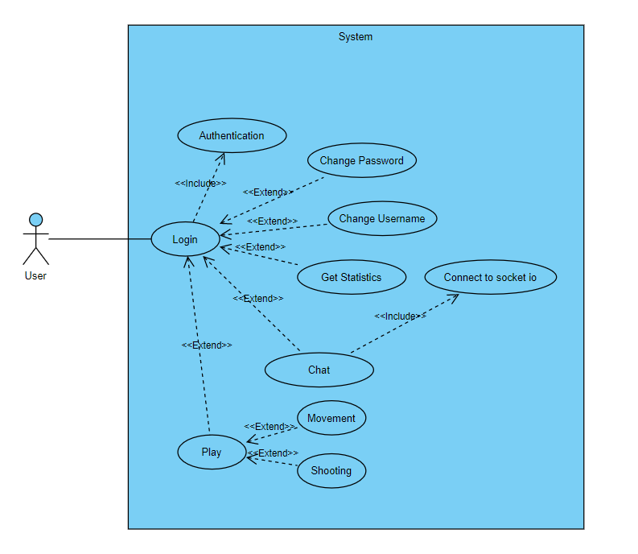Figure ‎5.2.1: Zombie Raid Use Case Diagram

## Use Case Specification for Login

### Brief Description

Provide basic authentication means, for users to log into their account and have access to the game and webapp features.

### Actors

Any User with an account is an Actor for this project.

### Basic Flow of Events

The user fills his information, clicks the login button, an authentication service is called with provided data, if its valid, the system allows the user to have access to their accounts and game.

### Alternative Flows of Events

The user fills his information, clicks the login button, an authentication service is called with provided data, if its invalid, the system responds with an error message stating that the provided data is incorrect.

### Special Requirements

Security

### Preconditions

User must have an account through registration

### Postconditions

None

### Extension Points

Play: Logged in users have access to the game which includes functionalities of its own such as movement mechanics, shooting.

Change Username/Password: Users logged on the webapp can modify their username and password under the account screen

Get Statistics : Users logged on the webapp have access to all their in-game statistics such as records of all their scores and a leaderboard for all user scores.

Chat: Users logged on the webapp have access to a public chatroom which they can use after connecting to a socket.

## Conclusion

The diagram above shows that the key to access all features of this project is the Login step.

# : Domain Analysis

## Introduction

In this chapter we will visualize the database tables for this project through a Class Diagram designed during the project modeling phase.

## System Class Diagram

We show below the Class Diagram used to model the database.

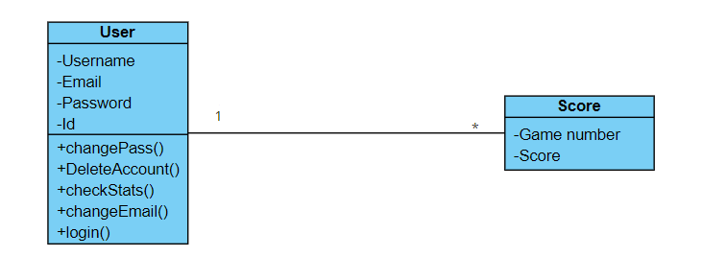

Figure 6.2.1 System Class Diagram

### Class Diagram Breakdown

Since the main product is the game, we’ve decided not to over-complicate the database and only store relevant information.

This is why we’ve included two tables:

* User:

Properties: Username, Email, Password, ID

Methods: Play, Register, Login, Modify Username/Password, View statistics

* Score:

Properties: Score, User ID, ID, Date

* Relationships:

The User has a one-to-many relationship with the Score as a user can have multiple scores stored.

### Why is Chat not stored in a table?

This was mentioned previously in Section 2.3, since storing chat unencrypted can lead to privacy issues, and since the chat is a public chatroom and not one-to-one, many users will be chatting at the same time, we’ve chosen not to store any chat records as is.

This leaves an issue for future updates where we might implement one-to-one chat, which cannot be done before building an extremely secure system with end-to-end encryption. Therefore, a Chat table will be implemented after fund acquisition when we can afford to properly implement a robust system.

## Conclusion

In this chapter we’ve discussed the database structure and explained why we chose simplicity over unsecure implementations that could compromise user safety and privacy.

# : Interaction and Data Flow Diagrams

## Introduction

In this chapter we will visualize and discuss some of the Interactions that might occur between the user and the system in addition to Data Interactions occurring between system components

## Sequence Diagrams

Sequence diagrams demonstrate the interactions that occur between User and System.

### Login Sequence Diagram

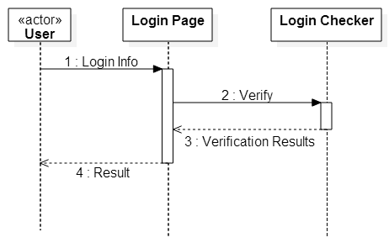

Figure 7.2.1.1: Sequence Diagram for Login

The figure above shows the sequence of actions that occur after the user presses Login, first the input fields are read and sent to the API, the server performs a Login Check through Backend Services then returns a result array, the result is then processed by the Interfaces to either allow access or deny it.

## Data Flow Diagram

Figure 7.3.1 System Data Flow Diagram

The figure above shows the Level-0 (Context Diagram) which is the basic overview of the whole system.

At the center we have the system connected to all other functionalities through backend APIs

## Conclusion

As can be seen from the diagrams so far, all functionalities and interactions go through the same sequence of actions: route calling -> controller -> service -> data access -> response

# : Software Architecture and Design

## Introduction

In this chapter we will breakdown the system into Physical Tiers and Logical Layers explaining the roles of each.

## Physical Tiers

Client Tier

Business Tier

Data Tier

## Logical Layers

Presentation Layer (Front-end/UI)

Service Layer (Web service layer, exposing APIs)

Domain Layer (Business Layer, Domain Model, Domain Service)

## Architectural Patterns

**Backend:**

The backend is structured as follows:

* Routes (Providing the routes to expose the APIs for the clients)
* Controllers (Handle the routes and combine various Services to perform a task)
* Services (Handle a specific task such as Database querying)

**Frontend:**

The website’s frontend is designed in Angular in a modular way such that every component handles a specific task and can be re-usable in any other project

The game’s frontend is designed in Unreal Engine using blueprints and OOP concepts so that every component created can be easily imported in another game (ex: AI model)

## Conclusion

We can conclude that this project implements 5 layers

* User Interfaces
* APIs
* Business Logic
* Data Access Layer
* Database

This is a modern approach to project design as it keeps modules decoupled which improves their re-usability and rigidity.

**More on the architecture, environment, and frameworks in Chapters** **12** **,** **13** **,** **14** **where we breakdown the layers behind every side of this project in details.**

# : User Interface Design

## Introduction

In this chapter we will display preliminary UI sketches in comparison to their final version with brief explanations for each.

## Preliminary UI Sketches

### Chat Room

The figure below shows the old Chat Room design as a temporary way to test the Backend functionalities

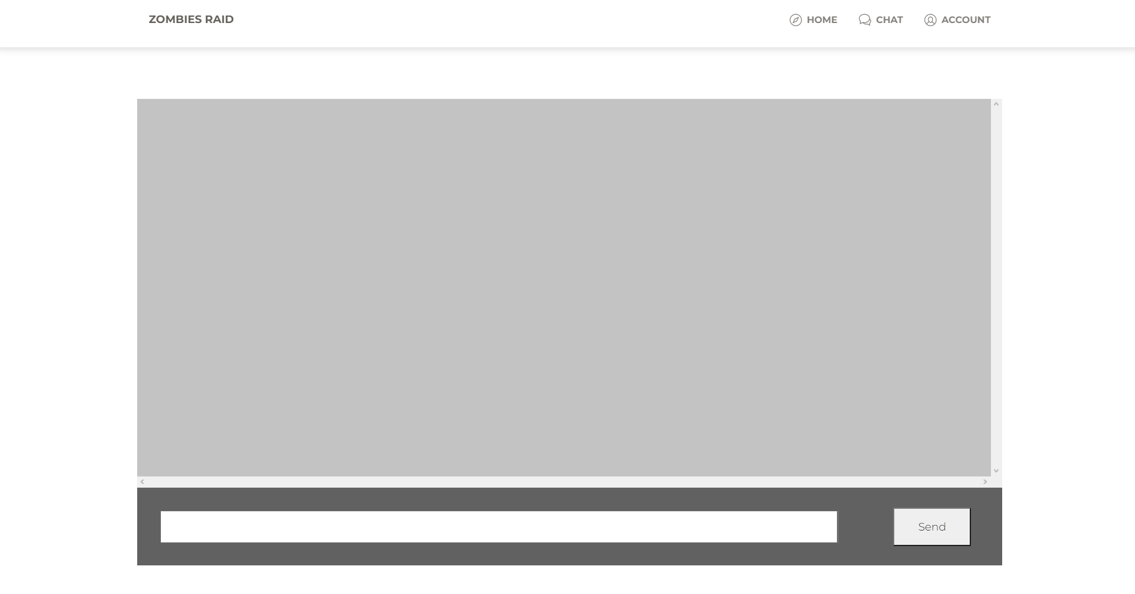

Figure ‎9.2.1 Preliminary chat room UI

### Game Login Screen

The figure below shows the old Game Login Screen design as a temporary way to test the Login API in-game.

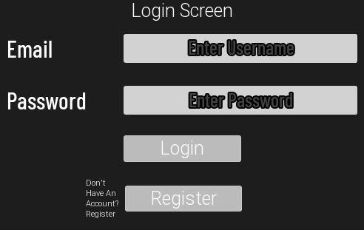

Figure ‎9.1.2 Preliminary game login screen UI

## Final UI Design

### 9.3.1 Chat Room

The figure below shows the final version of the Chat Room after testing and implementing its functionality.

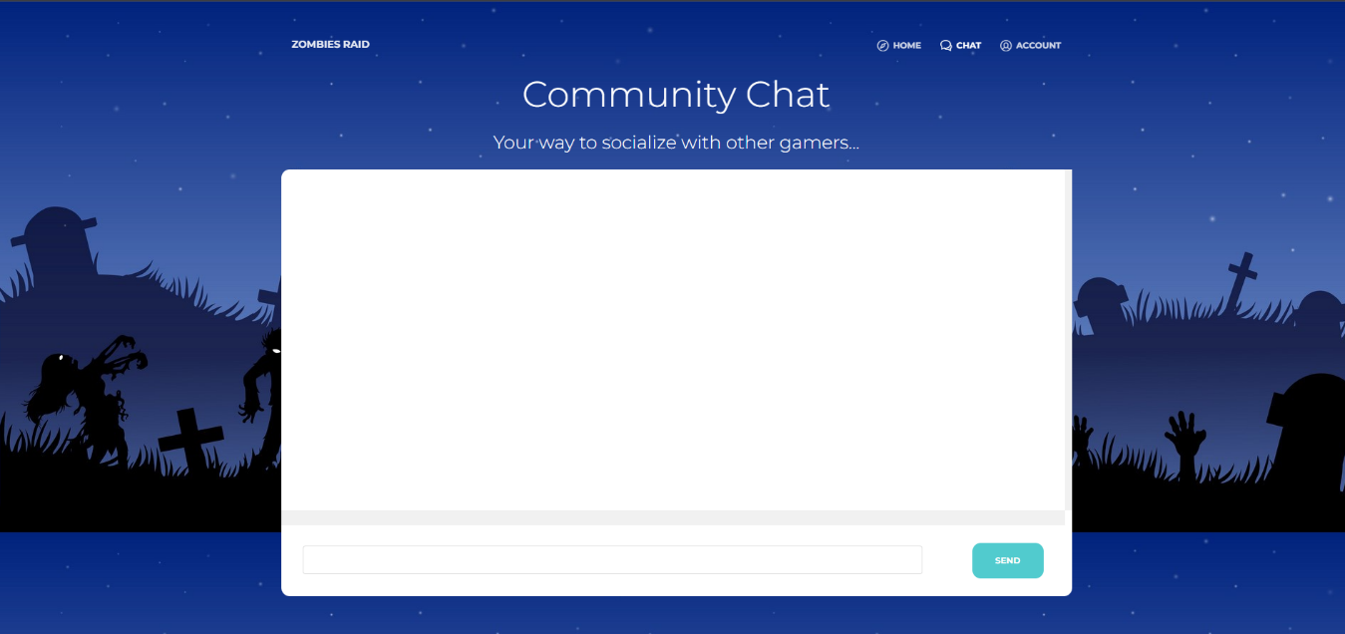

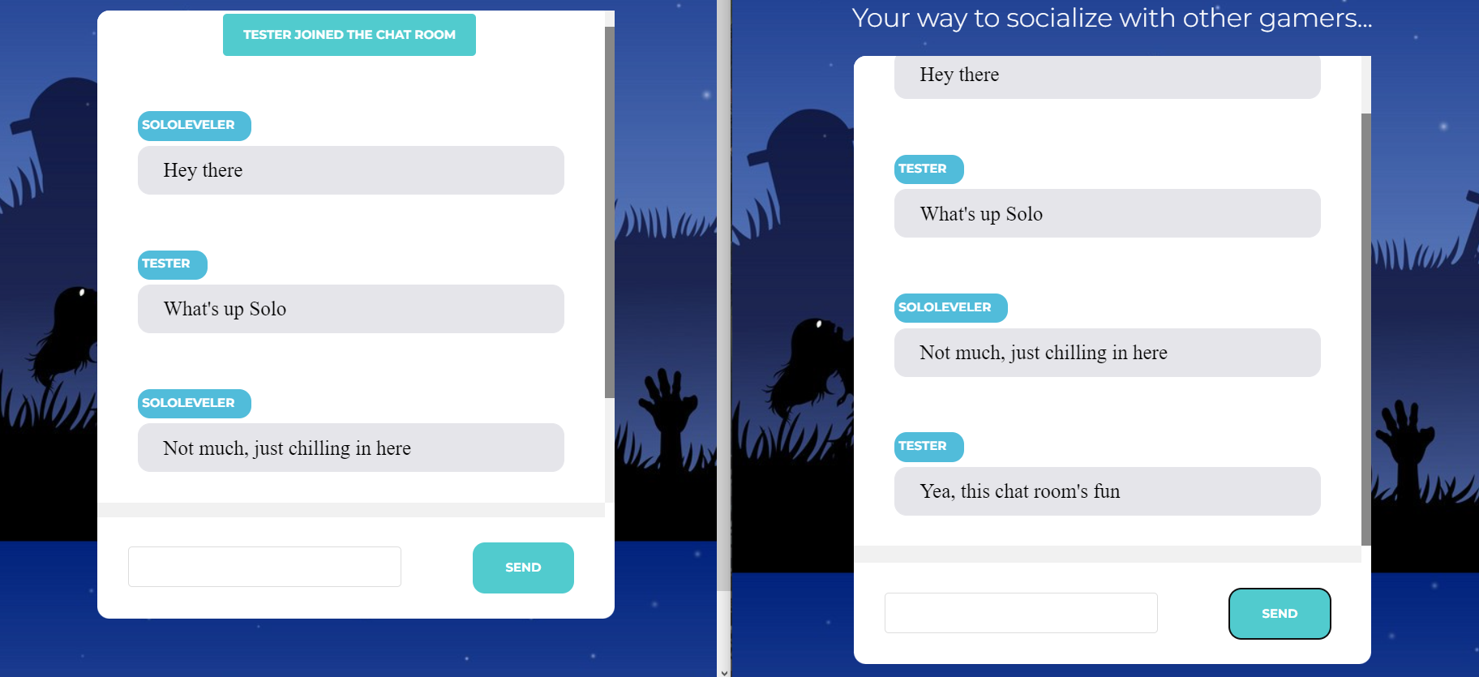

Figure ‎9.3.1 Final chat room UI

### 9.3.2 Home Page

Figure 9.3.2 Website Home Page

### 9.3.3 Website Login and Registration Screens

The figure below shows the final version of the Login and Registration pages.

Users with no account can click the Register button to create a new account then log on

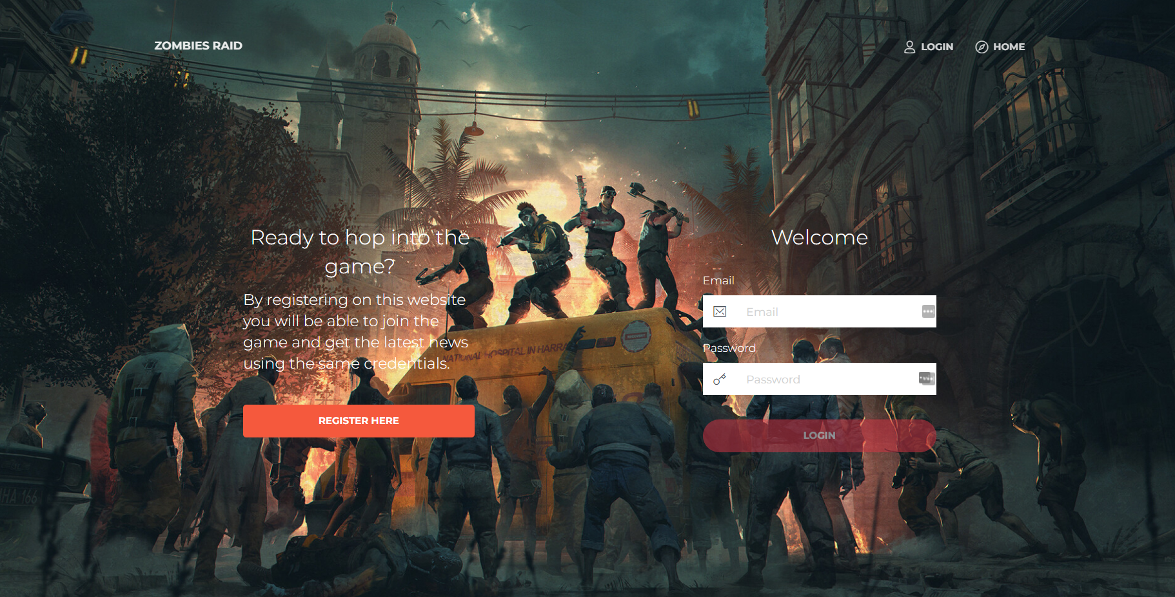

Figure ‎9.2.3.1 Final Login Website UI

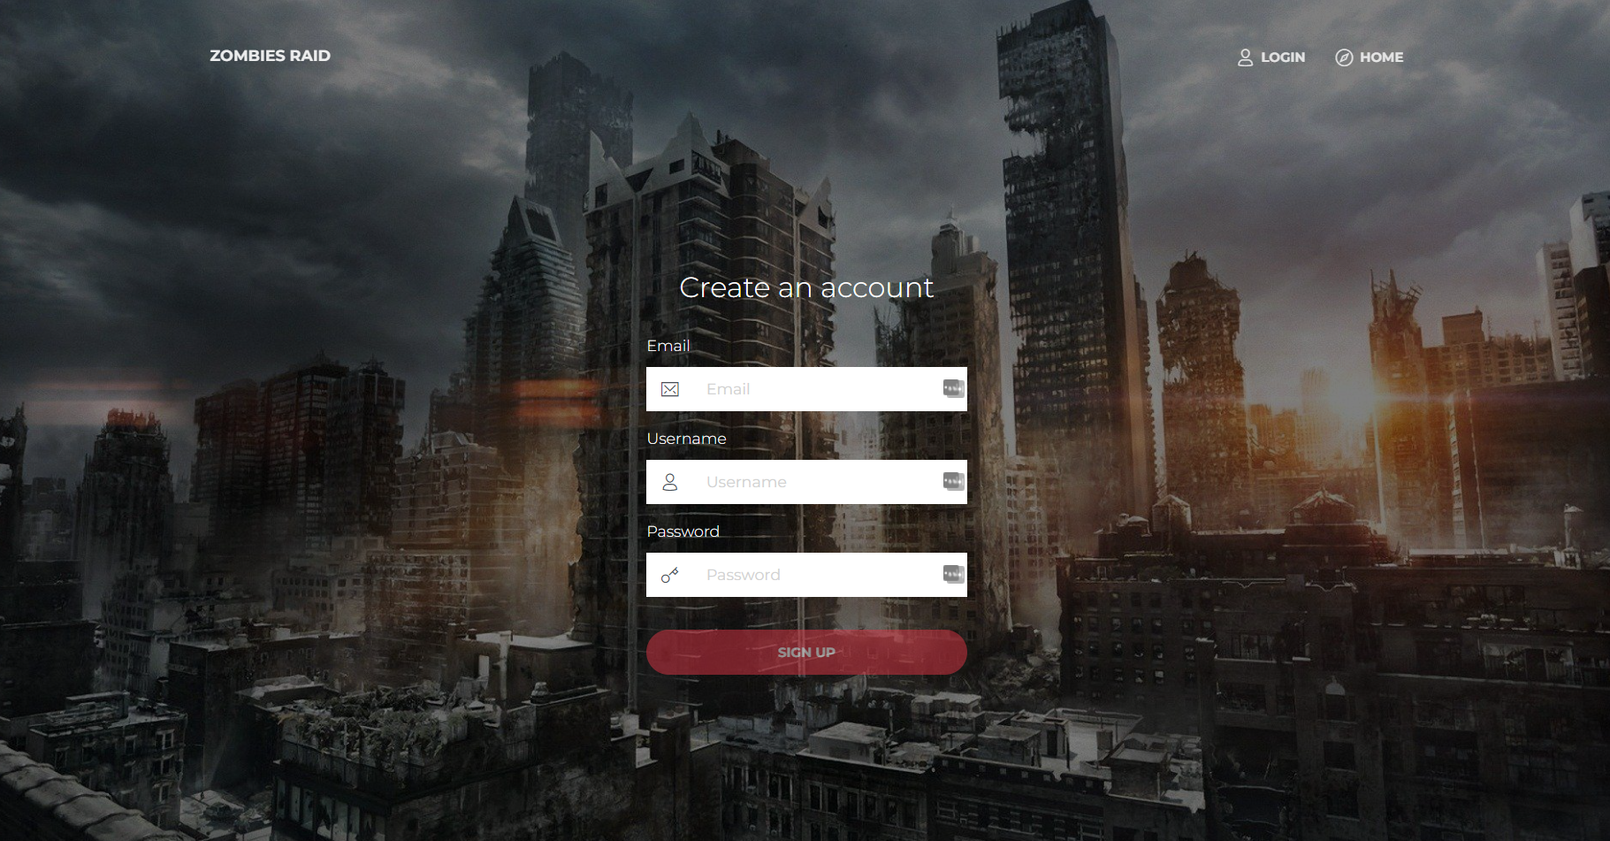

Figure ‎9.3.3.2 Final Registration Website UI

### 9.3.4 Website Account Screens

The figure below shows the final version of the account page.

Users can change their username, password or delete their account. In addition to navigating to the statistics page to check their game scores.

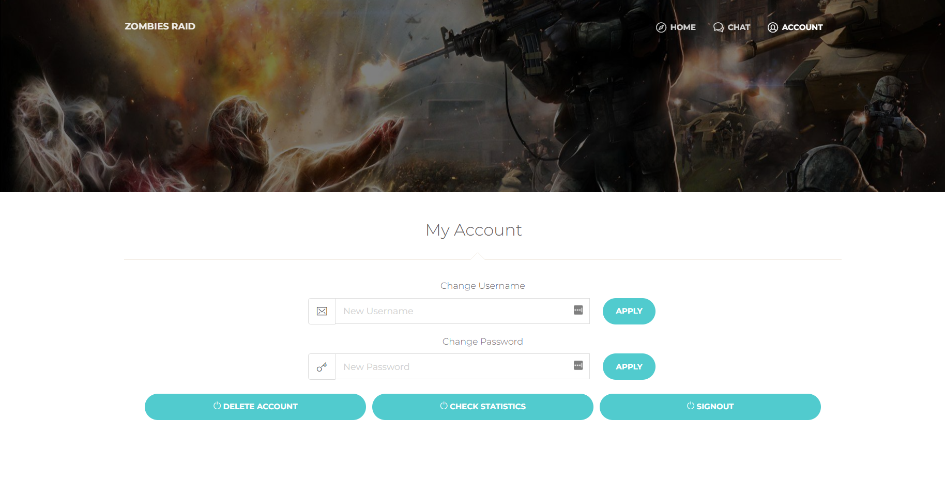

Figure ‎9.3.4 Final Account Page Website UI

### 9.3.5 Website Statistics Page

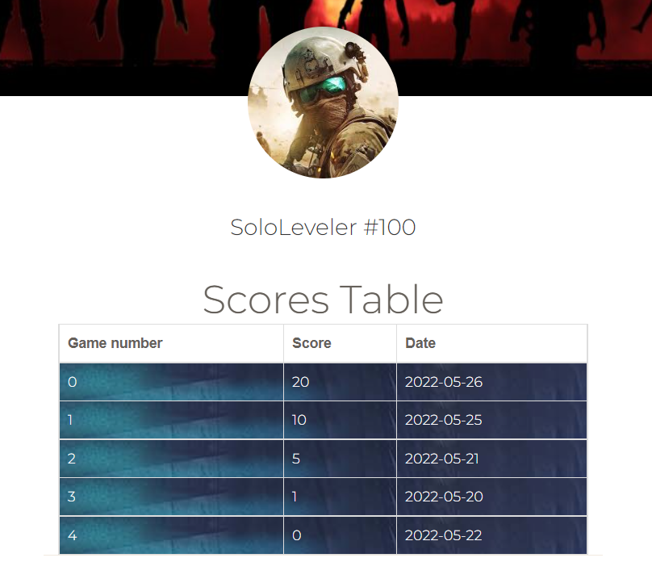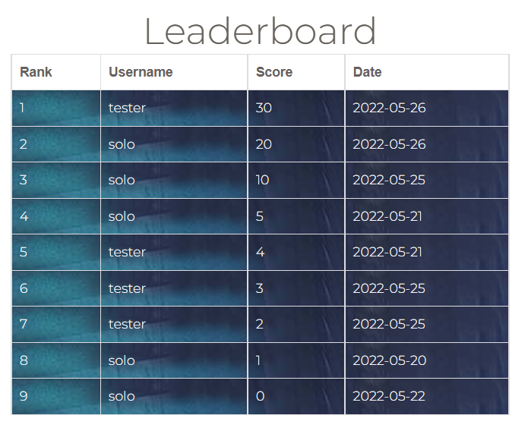

Figure ‎9.3.5.1 Final Statistics Page

### 9.3.6 Final Game Login Screen

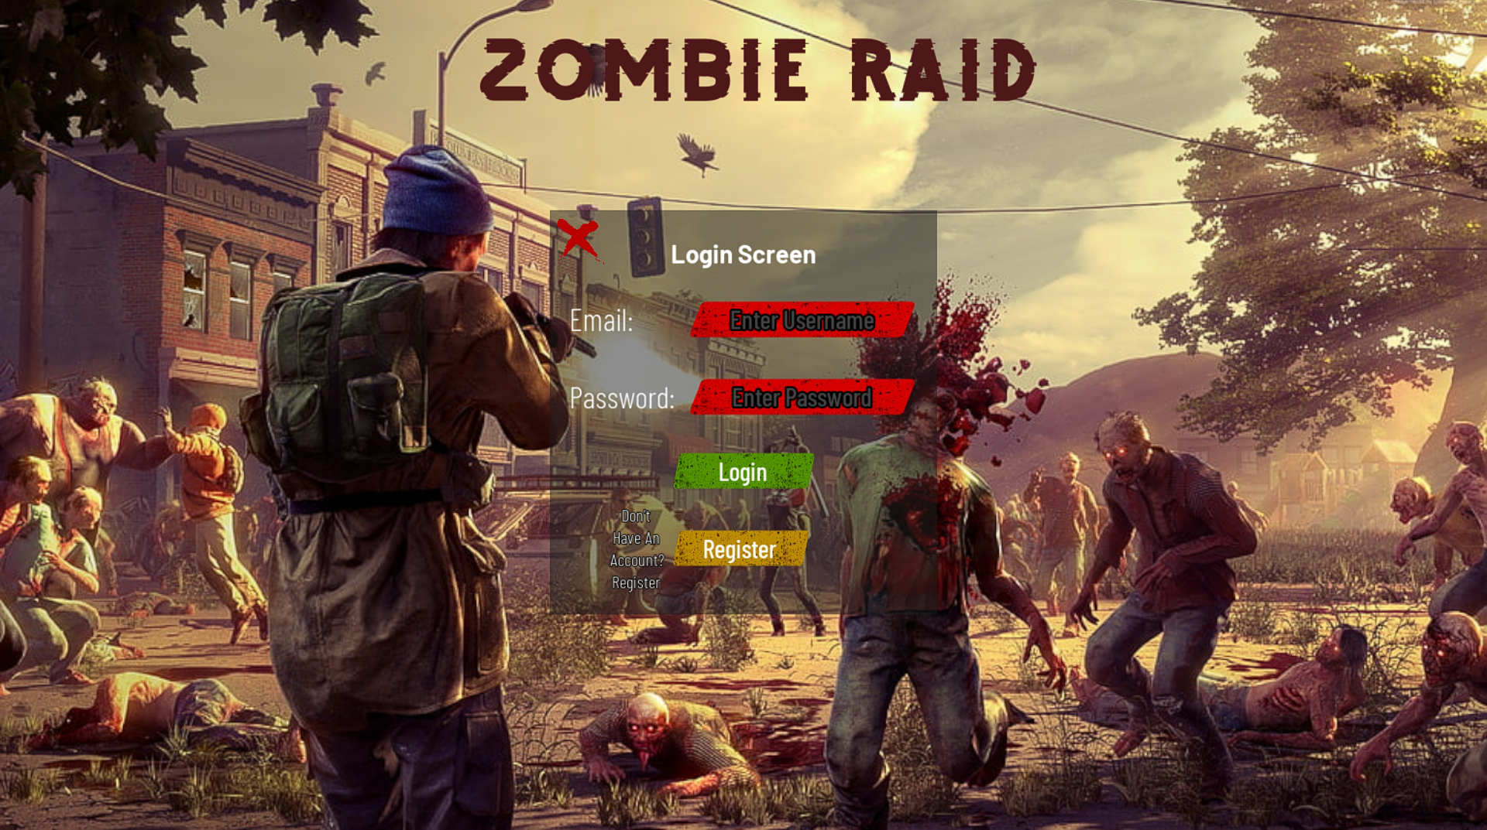

Figure 9.3.6.1 Final Game Login Screen

### 9.3.7 Final in Game UI And Environment

This picture shows the health and the shield of the player both displayed in the bottom left of the screen. In the upper left corner, we can see the current wave that the player is in and the number of zombies alive in the current wave. On the bottom right of the screen we can see the weapon bar of the player where the current equipped weapon is shown with the current magazine bullets and the max bullets it can hold.

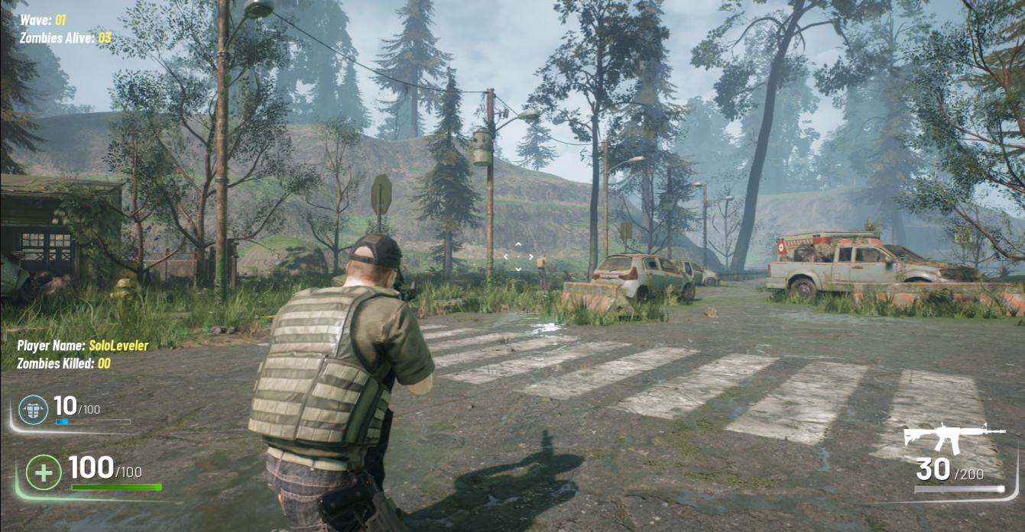Figure ‎9.3.7.1 Final Game UI And Environment

## Conclusion

We can tell from the pictures above that the preliminary UI sketches were designed for the sole purpose of testing their respective functionalities in the backend, then were replaced by their final versions after validation.

**The step-by-step process for building this project are detailed in Chapters** **12** **,** **13** **,** **14** **where we breakdown the layers behind every side of this project.**

# : Coding Samples

## Introduction

In this chapter we will display snippets of the coding and testing that happened behind the scenes, **more on their exact details will be explained in Chapters** **12** **,** **13** **,** **14**

## Code Blocks

Here are snippets of some notable code blocks:

### Socket.io

Socket.io is a library used in the backend to enable event driven programming which was used for the real time chat.

Figure 10.2.1: Socket.io Sample code (chat.service,js)

module.exports = (io, socket) => {

    let _username = '';

    const disconnect = () => {

        let notifyMsg = new Message('server', 'server', `${_username} left the chat room`);

        socket.broadcast.emit('message', notifyMsg);

    }

    const broadcastMessage = (msg) => {

        console.log(msg);

        socket.broadcast.emit('message', msg);

    }

    const broadcastChatMessage = (msg) => {

        console.log(msg);

        socket.broadcast.emit('chat-message', msg);

    }

… /*Other events*/ }

### Login Service (user.service.js)

This is code sample from the login function in the user service file which is part of the data access layer that queries the database to call the stored procedure named sp Login.

exports.login = async function (email, password) {

*try* {

    let user = *await* new sql.Request()

      .input("EMAIL", email)

      .input("PASSWORD", password)

      .execute("sp_Login");

*return* user.recordset;

  } *catch* (error) {

    console.log(error);

  }

};

Figure 10.2.2: User login service (user.service.js)

### Get User Score by Email Service (score.service.js)

This is code sample from the get user score by email function in the score service file which is part of the data access layer that queries the database to call the stored procedure that retrieves a specific user’s score.

exports.getUserScoreByEmail = async function (email) {

*try*{

        let scores = *await* new sql.Request()

        .input('EMAIL', email)

        .execute('sp_GetScoreByEmail');

*return* scores.recordset;

    } *catch* (error)

    {

        console.log(error);

    }

}

Figure 10.2.3: Get user score by email service (score.service.js)

### Login Stored Procedure (MSSQL)

This is an example of a stored procedure in the database that performs a login verification query. It returns the user with the matching email and password provided to it.

ALTER PROCEDURE [dbo].[sp_Login]

-- Add the parameters for the stored procedure here

@EMAIL NVARCHAR(50),

@PASSWORD NVARCHAR(50)

AS

BEGIN

SELECT *

FROM TBL_USER

WHERE (email=@EMAIL and password=@PASSWORD)

END

Figure 10.2.4: Login stored procedure (MSSQL)

## Conclusion

This chapter provided some samples of codes, queries and algorithms that laid the foundation for all the functionalities of this project.

# : Collaboration and Individual Contribution

## Introduction

In this chapter we will breakdown the individual and collective contributions of the team members, in addition to descriptions of the workflow and process.

## Collaboration Approach

Our daily communication was done online on Discord, where we share our progress, discuss next steps, and add to the report.

A weekly physical meeting was held at one of our houses to test the whole project together (Game, Website, Backend)

## Problems that Occurred

The three of us are very good friends so no “unprofessional” behaviors occurred, we did have some miscommunication every now and then regarding some of the tasks that needed to be done, however, these were handled immediately and fixed on the spot.

## Individual Contribution Breakdown

Table 11.4: Individual Contribution

|  |  |  |  |
| --- | --- | --- | --- |
| **Task** | **Anthony** | **Bernard** | **Oscar** |
| Website Frontend | 10% | 80% | 10% |
| Game | 10% | 10% | 80% |
| Backend | 80% | 10% | 10% |
| Report | 33% | 33% | 33% |

## Conclusion

We can conclude from the table and explanations above that the work was split equally between the team members with everyone handling the task he is best at and adapting to the feedback of his teammates. In brief, good friends build good projects.

# : Detailed Game Breakdown

## Introduction

In this chapter, we will provide an extremely detailed breakdown of the development process of the game the framework used and the environment for the development.

## Framework

The framework used for the development of the game is Unreal Engine 5. Unreal engine is the lead game developing engine, used in developing multiple Triple A games available on the market throughout the years like Mortal Kombat, Tekken, XCOM and now even Electronic Arts are ditching their own engine in favor of unreal engine with their upcoming and most successful title FIFA.

### Methodologies

At the core of unreal engine lies C++ which is the most used programming language when in need of performance and optimization. Unreal engine also introduced the concept of blueprints which falls under the category of visual scripting. Blueprints are built on top of C++ as predefined classes that can be accessed and modified through code or visually to perform specific tasks.

Which means that developers have a choice to make either develop visually which will increase the speed of the release of the product while still maintaining full control over the end result or use vanilla C++ which gives them more control over the performance of the product or use both of them which was the case in this project.

Since C++ is an object-oriented language and blueprints are just classes built with C++ the end result of an unreal engine project is a fully modular game with every component easily reusable in other projects.

## Zombie Raid Development Samples

In this section we demonstrate some blueprints implemented in unreal engine to implement one of Zombie Raid’s core functionalities: Equip Weapon Function, Player Death Function, Zombie Deal Damage Function.

### Equip Weapon Blueprint

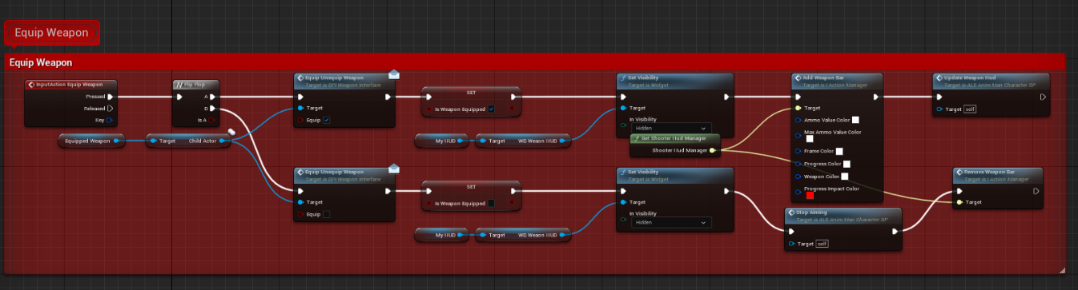

Figure 12.3.1 Equip Weapon Blueprint Function

First of all, when the player presses the equip weapon button, we check if the player is holding any weapon to begin with if not then the player plays an animation and picks up his primary weapon, then the weapons data gets updated and the HUD displays the current weapon name, its image, and the bullets in the magazine.

### Equip Weapon Blueprint

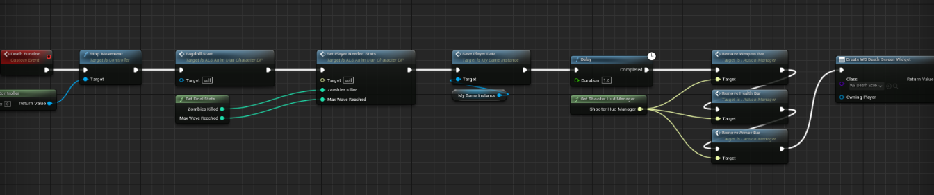

Figure 12.3.2 Death Blueprint Function

First of all, we start by stopping the player’s movement and input, then we activate the ragdoll collision preset in order to have the player enter ragdoll mode, then we set the player stats in a score record (to push to the database), save the player data to the locally, finally we hide all UI components and display the death screen.

### 12.3.3 Zombie Deal Damage Blueprint Function

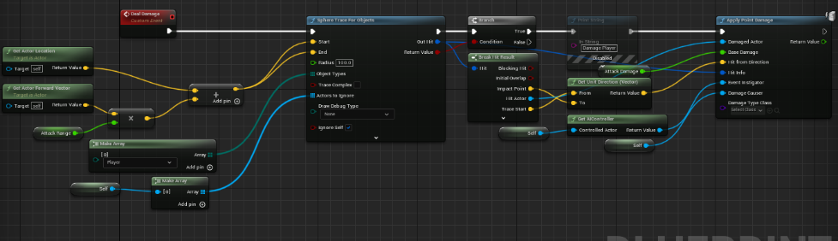

Figure 12.3.3 Zombie Deal Damage Blueprint Function

First, we start by performing sphere tracing to look for objects, the main object is the player.

The sphere starts from the zombie’s location and expends forward linearly with an attack range specified.

If the tracer collides with the player, we apply damage to the player based on a specified damage variable specific to each zombie type.

Else, nothing happens.

### Login HTTP POST Request Blueprint

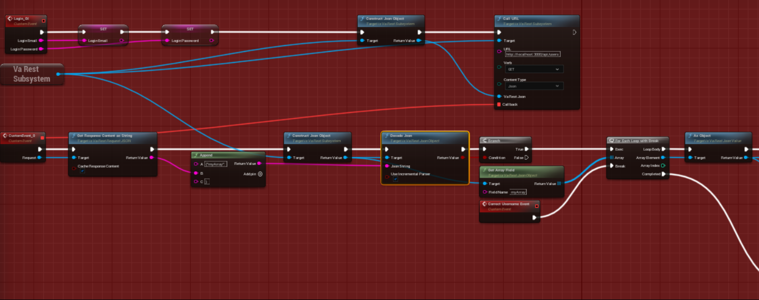

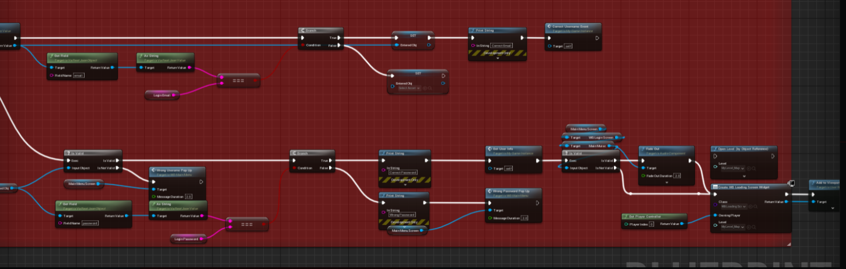

Figure 12.3.4 Login HTTP Call Blueprint

For HTTP Calls in unreal, we’ve used the VaRest plugin.

First, we start by collecting the inputted Email and Password from the Login Menu,

Then we construct a JSON Object to be sent to the HTTP POST Request through its body, this API returns a user if it’s found with the specific parameters passed.

If a user is returned, then the email and password match so we can proceed to the game.

### Create Score HTTP POST Request Blueprint

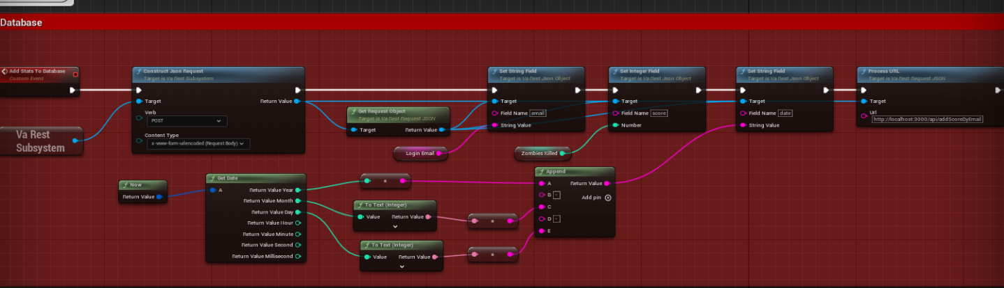 Figure 12.3.5 Create Score HTTP Call Blueprint

Similarly, to the Login POST Request, we start by creating the Score object based on the number of zombies the player has killed, this Score object contains the email, score, and the date of creation. This object is then appended to the request’s body and sent to the create score API.

## Game Demo

A video demonstrating the gameplay can be watched [here](https://www.youtube.com/watch?v=Z0wta5W_g5c).

# : Detailed Frontend Breakdown

## Introduction

In this chapter, we will provide an extremely detailed breakdown of the development process of the frontend the framework used and the environment for the development.

## Framework

The framework used for the development of the game is Angular, why?

Because it’s made by Google, we trust google with our data daily, so why not trust it to be the base for this project.

Angular is great for big projects due to the abundance of features it provides, countless themes, services, design packs…

### Methodologies

Angular strictly abides OOP designs, unlike developing with plain JavaScript, Angular favors TypeScript which is a superset of JavaScript that introduces types, this enables OOP features and best practices as the type of data is always known.

Angular has a modular structure, so all services, components and models are arranged in modules, this emphasizes on re-usability and enables de-coupled development which is less error prone as it makes it much easier to pinpoint the root error.

Every element of Angular uses classes, components, models, services, guards… are all classes, some with Directives which give them special attributes. This, combined with dependency injection, opens door for unlimited possibilities, easy scalability, and great performance.

### Project Structure

The project has the following structure:

* Components
* Models
* Services
* Shared
* Guards

### Development Steps

Since none of us are designers, the first step was finding a suitable HTML template that we could ‘Angularize’ (The process of turning a plain HTML/JS/CSS template into an Angular project by modularizing it).

Then, we’ve split the section we required and turned chunks of HTML into components that could be re-used at any point via an Import statement.

Next, it was time to implement some functionalities by making HTTP requests to the backend which required the creation of a service: authentication.service.ts which will contain the functions that make HTTP calls via Angular’s HttpClientModule by injecting it into the service’s constructor:

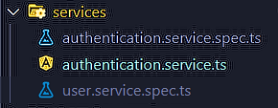

Figure 13.2.3.1 authentication service file

  constructor(private http : HttpClient) { }

Figure 13.2.3.2 Injecting HTTP Client into a service

The first functions implemented were Register and Login:

login(email:string, password:string) : Observable<any>

  {

    let formData = new FormData();

    formData.append('email', email);

    formData.append('password', password);

    let loginUrl = this.url+'login';

*return* this.http.post(loginUrl, formData);

  }

Figure 13.2.3.3 Login HTTP Request

register(email:string, password:string, username:string) : Observable<any>

  {

    let formData = new FormData();

    formData.append('email', email);

    formData.append('username', username);

    formData.append('password', password);

    let loginUrl = this.url+'register';

*return* this.http.post(

      loginUrl,

      formData,

      {responseType: 'text'}

      );

  }

Figure 13.2.3.4 Register HTTP Request

These functions are then called by the components that need them by simply subscribing to the service and awaiting response.

Once a User is signed in, we had to find a way to store their username, ID and email into an environment that does not get destroyed on refresh, cookies seemed like the right choice and so we’ve implemented functions to create, get, delete cookies from local storage in a new service.

public setCookie(params: any) {

    let d: Date = new Date();

    d.setTime(

      d.getTime() +

        (params.expireDays ? params.expireDays : 1) * 24 * 60 * 60 * 1000

    );

    document.cookie =

      (params.name ? params.name : '') +

      '=' +

      (params.value ? params.value : '') +

      ';' +

      (params.session && params.session == true

        ? ''

        : 'expires=' + d.toUTCString() + ';') +

      'path=' +

      (params.path && params.path.length > 0 ? params.path : '/') +

      ';' +

      (location.protocol === 'https:' && params.secure && params.secure == true

        ? 'secure'

        : '');

  }

Figure 13.2.3.5 Set Cookie Function

Now that was the project was well structured, implementing the remaining functionalities became easier.

Here’s when an issue surfaced, users were able to access restricted pages without logging in by pasting the URL, to solve this problem, Angular provide a convenient solution called “Guards”.

Guards, as the name suggests, are classes that can block the activation of a component if a condition is not met , this condition became the existence of the UID cookie , which meant the user logged in.

*export* class AuthGuardGuard implements CanActivate {

  constructor(private cookie : CookieService)

*export* class AuthGuardGuard implements CanActivate {

  constructor(private cookie : CookieService)

  {

  }

  hasCookie()

  {

    let uid = this.cookie.getCookie('UID');

*if*(uid && uid != '') *return* true;

*return* false;

  }

  canActivate(

    route: ActivatedRouteSnapshot,

    state: RouterStateSnapshot): Observable<boolean | UrlTree> | Promise<boolean | UrlTree> | boolean | UrlTree {

*return* this.hasCookie();

  }

}

Figure 13.2.3.6 Auth Guard

The final feature that required different steps than what was already implemented is the Chat Room.

Since real-time chatting is a service provided by Socket io, the first step was connecting to a socket when the user enters the chat page and emitting an event that the server is listening to:

this.socket.emit('user-joined', this.username);

Figure 13.2.3.7 Socket io emit example

And then subscribing to events fired by the server:

this.socket.on('chat-message', (data: Message) => {

*if* (data) {

        let msg = new Message();

        msg.content = data.content;

        msg.type = data.type;

        msg.author = data.author;

        this.messages.push(msg);

        this.scrollToBottom();

      }

    });

Figure 13.2.3.8 Subscribing to events Example

By combining event listening and emission, the client and server can share a real-time connection.

## Chat Demo

A video demonstrating the chat can be watched [here](https://youtu.be/Pgwe-EEpxB8).

# : Detailed Backend Breakdown

## Introduction

In this chapter, we will provide an extremely detailed breakdown of the development process of the backend used by both the game and website, the framework, and the environment for the development.

## Framework

The framework used for the development of the backend is Node JS in combination with Express JS.

This combo has become the most popular backend service used by developers, specifically in *MERN* (MongoDB-Express.js-React-Node.js) and *MEAN* (MongoDB, Express.js, Angular,Node.js) stacks .

Node is simply a JavaScript runtime service capable of executing JavaScript files outside the web, this meant a whole new world of possibilities compared to the ‘tame’ JavaScript limited by the browser, developers became able to create their own libraries (and importing ones using npm which is the package manager) in JS and run it using Node.

This led to the creation of Express JS which is a backend framework for Node JS used for the creation of APIs.

### Backend Layers

We’ve mentioned splitting code into layers several times through this report, so it only makes sense that the backend is also layered into several levels each handling their own responsibilities.

These layers are:

* APIs
* Business Layer
* Data Access Layer

This led to the creation of the following project structure:

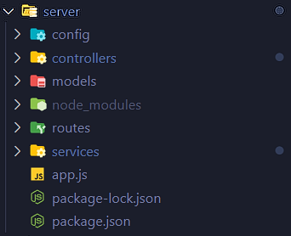

Figure 14.2.1.1 Backend Project Structure

Procedure processing routine:

* A procedure starts by the client making a call to an API defined in the routes folder
* The corresponding route then calls the controller responsible for handling the route
* The controller then calls various services that perform micro-actions such as calling a stored procedure in the database.

This structure means that every layer only has one purpose, this ensures a loosely coupled behavior and makes it extremely convenient to create new APIs, bugs can easily be pinpointed at their roots and handled immediately.

## Database

Even though we’ve mentioned MERN and MEAN stacks, both of which make use of Mongo DB as the database, we’ve chosen Microsoft SQL Server instead.

SQL server contains a sea of features which give it a competitive advantage over other databases, and this caught our attention.

### Stored Procedures

One feature that came handy during development is SQL Server’s Stored Procedures

Which are contained SQL Queries that can accept parameters and can be re-used as much as needed.

This feature gave , even a database, the sense of modularization which was exactly what we needed.

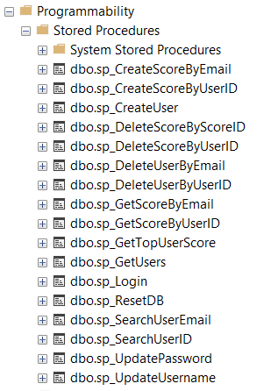

Figure 14.3.1.1 List of Stored Procedures created for this project

## Data Access Layers and Stored Procedures

Since SQL Server supports the creation of stored procedures, writing queries manually in the data access layers (or services in this case) is pointless.

For every functionality, a stored procedure was defined with the parameters it requires, this coupled nicely with the data accessing services defined in the backend.

An example of this combination is the Get Top User Scores function, which was used for the leaderboard:

ALTER PROCEDURE [dbo].[sp_GetTopUserScore]

@COUNT INT,

@SORTBY NVARCHAR(50),

@DIRECTION NVARCHAR(1)

AS

BEGIN

-- SET NOCOUNT ON added to prevent extra result sets from

-- interfering with SELECT statements.

SET NOCOUNT ON;

SELECT TOP (@COUNT) username, score, date

FROM TBL_SCORE

INNER JOIN TBL_USER ON TBL_SCORE.user_id = TBL_USER.user_id

ORDER BY

CASE WHEN @DIRECTION = 'A' THEN

CASE

WHEN @SORTBY = 'DATE' THEN CONVERT(DATETIME, date, 102)

WHEN @SORTBY = 'SCORE' THEN score

END

END ASC,

CASE WHEN @DIRECTION = 'D' THEN

CASE

WHEN @SORTBY = 'DATE' THEN CONVERT(DATETIME, date, 102)

WHEN @SORTBY = 'SCORE' THEN score

END

END DESC

END

Figure 14.4.1 Get Top User Scores Stored Procedures

The above procedure takes 3 parameters:

* Count (number of records to retrieve)
* Sort By (the column to use for sorting , in this case Date and Score)
* Direction (ascending or descending)

So how did this mix with the data access services?

All we had to do now in these services is call the specific stored procedure (using the mssql package) and pass to it the parameters appended to the API Call (in its body, encoded)

As follows:

exports.getTopUserScore = async function (count, sortby, direction) {

*try*{

        let scores = *await* new sql.Request()

        .input('COUNT', count)

        .input('SORTBY', sortby)

        .input('DIRECTION', direction)

        .execute('sp_GetTopUserScore');

*return* scores.recordset;

    } *catch*(error)

    {

        console.log(error);

    }

}

Figure 14.4.2 Get Top User Score service

## Socket io

The last step to implement the backend for this project is the real-time chat room, for this we made use of the socket io package:

Where socket is a chat service with the sole purpose of handling events.

module.exports = (io, socket) => {

    let _username = '';

    const disconnect = () => {

        let notifyMsg = new Message('server', 'server', `${_username} left the chat room`);

        socket.broadcast.emit('message', notifyMsg);

    }

    const broadcastMessage = (msg) => {

        console.log(msg);

        socket.broadcast.emit('message', msg);

    }

    const broadcastChatMessage = (msg) => {

        console.log(msg);

        socket.broadcast.emit('chat-message', msg);

    }

    const connect = (username) => {

        _username = username;

        console.log(_username + " connected");

        let notifyMsg = new Message('server', 'server', `${_username} joined the chat room`);

        socket.broadcast.emit('message', notifyMsg);

    }

    socket.on('user-joined', connect);

    socket.on('message', broadcastMessage);

    socket.on('chat-message', broadcastChatMessage);

    socket.on('disconnect', disconnect);

  }

Figure 13.2.3.9 Chat Service Implementation

## API Testing

Since the backend functionalities are developed prior to their user interface, we needed a tool to test these endpoints.

For such purposes, Postman is a great tool that can test any type of HTTP Requests to any endpoints with the possibility to pass parameters through the body.

### Postman Structure

For every backend API, a Postman request was created:

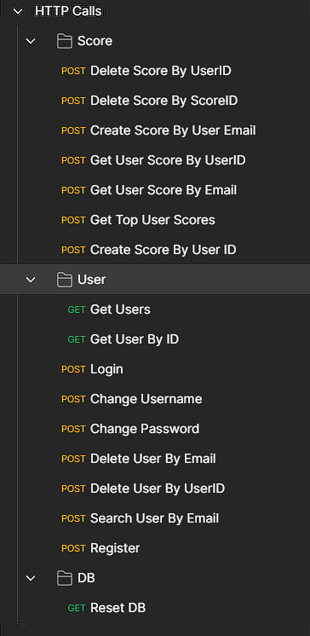

Figure 14.6.1.1 Postman Requests

These requests contained all necessary information to call an endpoint: URL, Request type, Parameters.

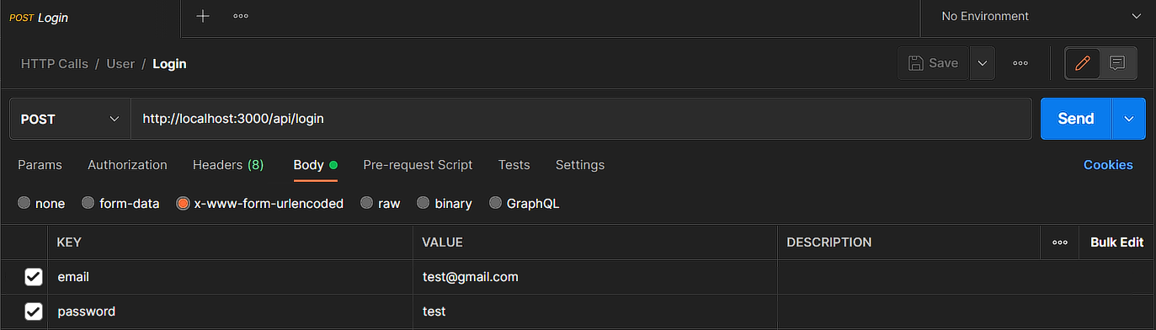

Figure 14.6.1.2 Postman Login Request

### Postman and improving team efficiency

Since the project isn’t hosted, each one of us had to install the necessary tools to run the server on his machine, this forced the non-backend developers to acquire certain knowledge about backend development that made it easier to communicate new ideas.

API Parameters:

Postman requests can be exported as a file and imported on any other machine, this gave us the ability to share the API Calls with their specific parameters, meaning that there was less ‘guessing’ and eliminated unnecessary meetings to explain these APIs

This way Postman doubled down as an API middleware that provided the team with all information necessary about an API

## Version Control and Open Sourcing

We’ve mentioned in the previous section the need for sharing the server amongst the team members as the project is not hosted.

This meant that the front-end, server and database needed to be constantly updated on our 3 machines, emails or drives were not an option anymore.

Here ‘s where version controlling and open sourcing came in, we installed git on our machines and committed every increment to a public repository on GitHub.

This made it easy for the backend developer to push new features with an updated database without worrying about creating issues for the rest of the team.

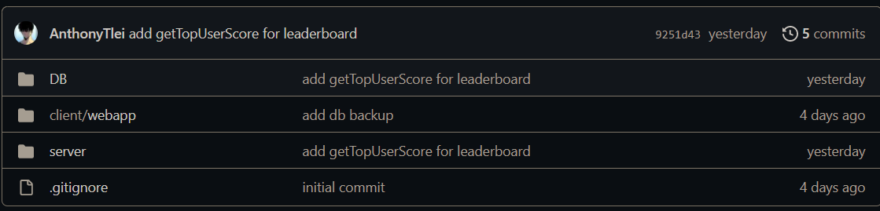

Figure 14.7.1 GitHub Repo

**The link to the project can be found** [**here**](https://github.com/AnthonyTlei/senior-project)**.**

* To run the project, make sure Angular CLI , Node, npm , and SQL Server are installed
* Open the client->webapp folder in a terminal and run “npm i” to install all packages listed in packages.json
* Run “ng serve -o” to open the webapp in your local browser
* Create an SQL Server Instance on your machine and configure its credentials
* Import the DB.bak file
* Open the server folder in a terminal and run the same “npm i”
* Run “nodemon app.js” to start the server
* The game build will be hosted separately due to its large size

# : Conclusions and Recommendations

## Summary of the Main Results

This senior project had the main aim of creating a Zombie shooter game that combines additional user interaction outside the game itself.

The game was built using Unreal Engine blueprints and C++, the website was written using TypeScript in Angular, the backend was written in JavaScript using Node.js, Express.js Socket.io, and the Database was built using Microsoft SQL Server

The first month was spent brainstorming, picking frameworks, designing the Class models, and researching similar projects.

The following two months were spent implementing new features and testing them until we hit a stable point.

## Main Contributions

* First, theoretically, since it involves many computers science fields such as Game development and Fullstack Development
* Second, technically, since we had to learn socket.io to build real-time chatting
* Finally, in this project we created a Game and a Webapp. This taught us a lot about collaboration as Both ends required the same backend and database which improved our communication and task handling.

## Possible Extensions and Future Work

There are still countless features that could be added to this project, let it be on the game or the webapp side, as games are infinitely scalable, and web-apps are built in a very modular fashion that adding/modifying/deleting features in easy to do.

Some features that could be added for example are:

* One to one chatting
* Friend lists
* Chatting in-game
* New game modes (such as co-op)
* An inventory system that can be viewed from the webapp
* New maps to play on
* In-game app purchases
* Password hashing
* End-to-end encryption

Just to name a few